Q1:
import java.util.*;
import java.util.Scanner;
class Juice {
private float price;
private String ingredients;
private String taste;
private static int count = 0;
public Juice(float price, String ingredients, String taste) {
this.price = price;
this.ingredients = ingredients;
this.taste = taste;
count++;
}
public void setPrice(float price) {
this.price = price;
}
public void setIngredients(String ingredients) {
this.ingredients = ingredients;
}
public void setTaste(String taste) {
this.taste = taste;
}
public float getPrice() {
return price;
}
public String getIngredients() {
return ingredients;
}
public String getTaste() {
return taste;
}
public static int getCount() {
return count;
}
public void display() {
System.out.println("Juice Price: " + price);
System.out.println("Juice Ingredients: " + ingredients);
System.out.println("Juice Taste: " + taste);
}
}
class FruitJuice extends Juice {
private String season;
private static int count = 0;
public FruitJuice(float price, String ingredients, String taste, String season) {
super(price, ingredients, taste);
this.season = season;
count++;
}
public void setSeason(String season) {
this.season = season;
}
public String getSeason() {
return season;
}
public static int getCount() {
return count;
}
public void display() {
super.display();
System.out.println("Season: " + season);
}
}
class VegetableJuice extends Juice {
private String origin;
private static int count = 0;
public VegetableJuice(float price, String ingredients, String taste, String origin) {
super(price, ingredients, taste);
this.origin = origin;
count++;
}
public void setOrigin(String origin) {
this.origin = origin;
}
public String getOrigin() {
return origin;
}
public static int getCount() {
return count;
}
public void display() {
super.display();
System.out.println("Origin: " + origin);
}
}
class MixedJuice extends Juice {
private static int count = 0;
public MixedJuice(float price, String ingredients, String taste) {
super(price, ingredients, taste);
count++;
}
public static int getCount() {
return count;
}
public void display() {
super.display();
}
}
class CitrusJuice extends FruitJuice {
private static int count = 0;
public CitrusJuice(float price, String ingredients, String taste, String season) {
super(price, ingredients, taste, season);
count++;
}
public static int getCount() {
return count;
}
public void display() {
super.display();
System.out.println("22k-4080 Arham Khan also likes citrus fruit juice");
}
}
class BerryJuice extends FruitJuice {
private static int count = 0;
public BerryJuice(float price, String ingredients, String taste, String season) {
super(price, ingredients, taste, season);
count++;
}
public static int getCount() {
return count;
}
public void display() {
super.display();
System.out.println("22k-4080 Arham Khan also likes berry fruit juice");
}
}
class TropicalJuice extends FruitJuice {
private static int ctr3 = 0;
public TropicalJuice(float p, String i, String t, String s) {
super(p, i, t, s);
ctr3++;
}
public static int getCount3() {
return ctr3;
}
public void display() {
super.display();
System.out.println("22k-4080 Arham Khan also likes tropical fruit juice");
}
}
class LeafyGreenJuice extends VegetableJuice {
private static int ctr3 = 0;
public LeafyGreenJuice(float p, String i, String t, String o) {
super(p, i, t, o);
ctr3++;
}
public static int getCount3() {
return ctr3;
}
public void display() {
super.display();
System.out.println("22k-4080 Arham Khan also likes leafy green juice");
}
}
class RootVegetableJuice extends VegetableJuice {
private static int ctr3 = 0;
public RootVegetableJuice(float p, String i, String t, String o) {
super(p, i, t, o);
ctr3++;
}
public static int getCount3() {
return ctr3;
}
public void display() {
super.display();
System.out.println("22k-4080 Arham Khan also likes root veegtable juice");
}
}
class MixedVegetableJuice extends VegetableJuice {
private static int ctr3 = 0;
public MixedVegetableJuice(float p, String i, String t, String o) {
super(p, i, t, o);
ctr3++;
}
public static int getCount3() {
return ctr3;
}
public void display() {
super.display();
System.out.println("22k-4080 Arham Khan also likes mixed vegetable juice");
}
}
class FruitAndVeggieJuice extends MixedJuice {
private static int ctr3 = 0;
public FruitAndVeggieJuice(float p, String i, String t) {
super(p, i, t);
ctr3++;
}
public static int getCount3() {
return ctr3;
}
public void display() {
super.display();
System.out.println("22k-4080 Arham Khan also likes fruit and vegetable juice");
}
}
class SmoothieJuice extends MixedJuice {
private static int ctr3 = 0;
public SmoothieJuice(float p, String i, String t) {
super(p, i, t);
ctr3++;
}
public static int getCount3() {
return ctr3;
}
public void display() {
super.display();
System.out.println("22k-4080 Arham Khan also likes smoothie juice");
}
}
class Sale {
private int ID;
private String custName;
private float bill;
private int numOfFruitJuice;
private int numOfVeggieJuice;
private int numOfMixedJuice;
private static int id = 1;
public Sale() {
bill = 0;
numOfFruitJuice = 0;
numOfMixedJuice = 0;
numOfVeggieJuice = 0;
}
public Sale(String n) {
custName = n;
ID = id;
id++;
bill = 0;
numOfFruitJuice = 0;
numOfMixedJuice = 0;
numOfVeggieJuice = 0;
}
public void inc_num_fruit() {
numOfFruitJuice++;
}
public void inc_num_veggie() {
numOfVeggieJuice++;
}
public void inc_num_mixed() {
numOfMixedJuice++;
}
public void calc_bill(int p) {
bill = bill + p;
}
public int get_num_fruit() {
return numOfFruitJuice;
}
public int get_num_veggie() {
return numOfVeggieJuice;
}
public int get_num_mixed() {
return numOfMixedJuice;
}
public float get_bill() {
return bill;
}
public void display() {
System.out.println("Customer Name:" + custName);
System.out.println("Sales ID:" + ID);
System.out.println("Number Of Fruit Juices:" + numOfFruitJuice);
System.out.println("Number Of Vegetable Juices:" + numOfVeggieJuice);
System.out.println("Number Of Mixed Juices:" + numOfMixedJuice);
System.out.println("Bill:" + bill);
}
public static Sale operator(Sale a, Sale b) {
Sale temp = new Sale();
if (a.custName.equals(b.custName)) {
temp.custName = a.custName;
temp.bill = a.bill + b.bill;
temp.numOfFruitJuice = a.numOfFruitJuice + b.numOfFruitJuice;
temp.numOfMixedJuice = a.numOfMixedJuice + b.numOfMixedJuice;
temp.numOfVeggieJuice = a.numOfVeggieJuice + b.numOfVeggieJuice;
temp.ID = a.ID + b.ID;
return temp;
} else {
System.out.println("INVALID! Customer name is different");
return null;
}
}
}
public class Q1 {
public static void main(String[] args) {
Scanner scanner = new Scanner(System.in);
String name;
FruitJuice[] ptr1 = new FruitJuice[10];
VegetableJuice[] ptr2 = new VegetableJuice[10];
MixedJuice[] ptr3 = new MixedJuice[10];
System.out.println("Arham Khan");
System.out.println("22K-4080\n");
System.out.println("\tWelcome to The Juice Shop");
System.out.print("Enter your name: ");
name = scanner.nextLine();
Sale obj1 = new Sale(name);
Sale obj2 = new Sale(name);
int opt1, opt2, i = 0, j = 0, k = 0;
System.out.println("\nWe have following categories of juices available:");
do {
System.out.println("0-Check out");
System.out.println("1-Fruit Juice");
System.out.println("2-Vegetable Juice");
System.out.println("3-Mixed Juice");
System.out.print("Enter option number of type of juice to proceed: ");
opt1 = scanner.nextInt();
if (opt1 == 1 && i != 10) {
System.out.println("\t0-Main Menu");
System.out.println("\t1-Citrus Juice 399");
System.out.println("\t2-Berry Juice 599");
System.out.println("\t3-Tropical Juice 450");
do {
System.out.print("\tEnter option number to add juice for purchase: ");
opt2 = scanner.nextInt();
if (opt2 == 1) {
ptr1[i] = new CitrusJuice(399, "lemon,grapefruit and orange", "sweet and tangy flavour", "Winter");
i++;
obj1.calc_bill(399);
obj1.inc_num_fruit();
}
if (opt2 == 2) {
ptr1[i] = new BerryJuice(599, "strawberry,blueberry and raspberry", "sweet flavour", "Winter");
i++;
obj1.calc_bill(599);
obj1.inc_num_fruit();
}
if (opt2 == 3) {
ptr1[i] = new TropicalJuice(450, "lychee and papaya", "sweet and sour flavour", "summer");
i++;
obj2.calc_bill(450);
obj2.inc_num_fruit();
}
} while (opt2 != 0 && i != 10);
if (i == 10) {
System.out.println("Sorry! Limit reached for Fruit Juice");
}
}
if (i == 10) {
System.out.println("Sorry! Limit reached for Fruit Juice");
}
if ((opt1 == 2) && (j != 10)) {
System.out.println("\t0-Main Menu");
System.out.println("\t1-Leafy Green Juice 499");
System.out.println("\t2-Root Vegetable Juice 299");
System.out.println("\t3-Mixed Vegetable Juice 750");
do {
System.out.print("\tEnter option number to add juice for purchase: ");
opt2 = scanner.nextInt();
if (opt2 == 1) {
ptr2[j] = new LeafyGreenJuice(499, "kale,spinach and celery", "bitter and earthy taste", "Persia and England");
j++;
obj2.calc_bill(499);
}
if (opt1 == 2 && j != 10) {
System.out.println("\t0-Main Menu");
System.out.println("\t1-Leafy Green Juice 499");
System.out.println("\t2-Root Vegetable Juice 299");
System.out.println("\t3-Mixed Vegetable Juice 750");
do {
System.out.println("\tEnter option number to add juice for purchase:");
opt2 = scanner.nextInt();
if (opt2 == 1) {
ptr2[j] = new LeafyGreenJuice(499, "kale,spinach and celery", "bitter and earthy taste", "Persia and England");
j++;
obj2.calc_bill(499);
obj2.inc_num_veggie();
}
if (opt2 == 2) {
ptr2[j] = new RootVegetableJuice(299, "carrots,ginger and turnips", "bitter flavour", "Iran");
j++;
obj2.calc_bill(299);
obj2.inc_num_veggie();
}
if (opt2 == 3) {
ptr2[j] = new MixedVegetableJuice(750, "carrots,spinach,ginger and kale", "bitter and sour flavour", "Iran and England");
j++;
obj1.calc_bill(750);
obj1.inc_num_veggie();
}
} while (opt2 != 0 && j != 10);
if (j == 10) {
System.out.println("Sorry!Limit reached for Vegetable Juice");
}
}
if (j == 10) {
System.out.println("Sorry!Limit reached for Vegetable Juice");
}
} while (opt2 != 0);
}
if (opt1 == 3 && k != 10) {
System.out.println("\t0-Main Menu");
System.out.println("\t1-Fruit and Veggie Juice 799");
System.out.println("\t2-Smoothie Juice 750");
do {
System.out.println("\tEnter option number to add juice for purchase:");
opt2 = scanner.nextInt();
if (opt2 == 1) {
ptr3[k] = new FruitAndVeggieJuice(799, "strawberry,lychee,ginger and carrots", "sweet and sour taste");
k++;
obj2.calc_bill(799);
obj2.inc_num_mixed();
}
if (opt2 == 2) {
ptr3[k] = new SmoothieJuice(750, "spinach,pineapple and mango", "bitter and sour flavour");
k++;
obj1.calc_bill(750);
obj1.inc_num_mixed();
}
} while (opt2 != 0 && k != 10);
if (k == 10) {
System.out.println("Sorry!Limit reached for Mixed Juice");
}
}
if (k == 10) {
System.out.println("Sorry!Limit reached for Mixed Juice");
}
}while (opt1 != 0) ;
System.out.println("\nBill 01:\n");
obj1.display();
System.out.println("\nBill 02:\n");
obj2.display();
System.out.println("\n----Final Bill----");
Sale obj3 = Sale.operator(obj1, obj2);
obj3.display();
}
}

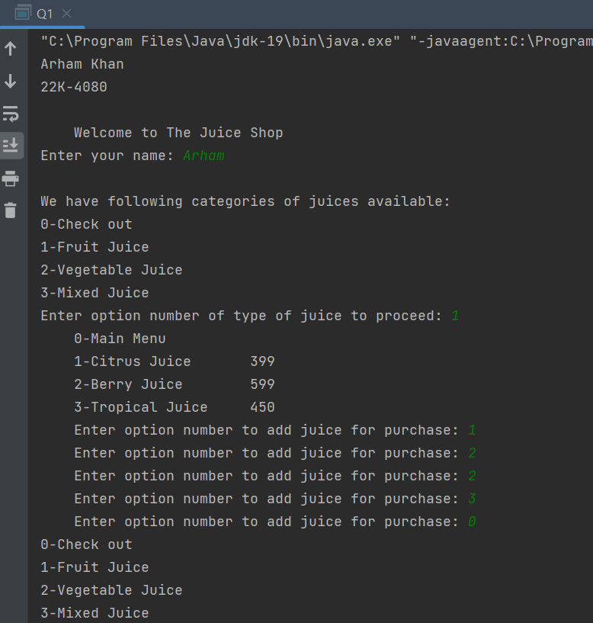

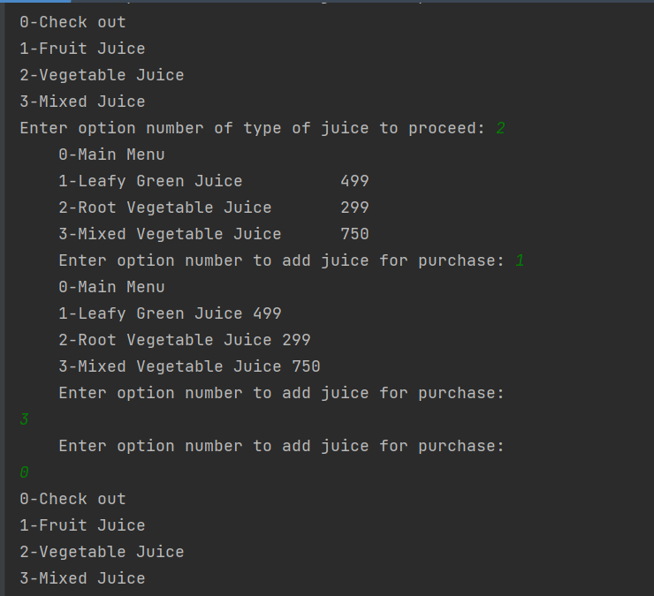
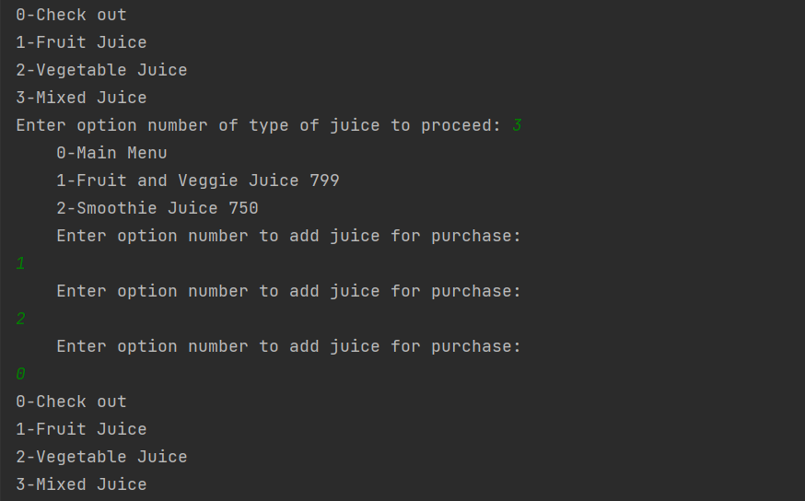
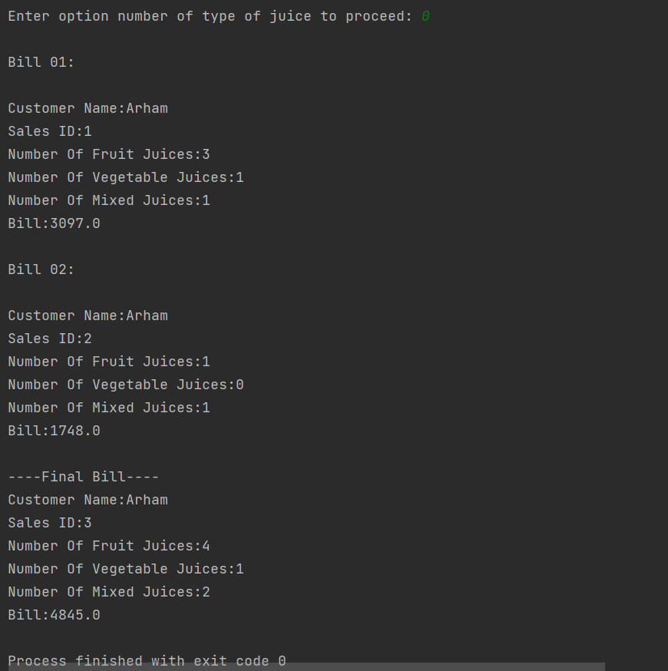

Q2:
import java.util.*;
class Course {
private String name;
private String code;
private int cred_hour;
private float gpa;
private String grade;
public void setGpa(float g) {
gpa = g;
}
public String getName() {
return name;
}
public float getGpa() {
return gpa;
}
public String getCode() {
return code;
}
public int getHour() {
return cred_hour;
}
public String getGrade() {
return grade;
}
public void setGrade(String g) {
grade = g;
}
public void setName(String n) {
name = n;
}
public void setCode(String c) {
code = c;
}
public void setHour(int cr) {
cred_hour = cr;
}
public void displayInfo() {
System.out.println("Course Name:" + name);
System.out.println("Course Code:" + code);
System.out.println("Credit Hours:" + cred_hour);
}
public void showCredHour() {
System.out.println("Credit Hours:" + cred_hour);
}
public void showCode() {
System.out.println("Course Code:" + code);
}
}
class Student {
private String ID;
private String name;
private int num_of_course;
protected Course[] courses = new Course[7];
private boolean verify_fees;
private float GPA;
private float due_amount;
private float semester_fees;
public void set_ID(String id) {
ID = id;
}
public void set_num_of_course(int n) {
num_of_course = n;
}
public void set_name(String n) {
name = n;
}
public float get_semester_fees() {
return semester_fees;
}
public void set_course_info(Course a, int j) {
courses[j].setName(a.getName());
courses[j].setCode(a.getCode());
courses[j].setHour(a.getHour());
courses[j].setGrade(a.getGrade());
}
public int calc_cred_hour() {
int temp = 0;
for (int i = 0; i < num_of_course; i++) {
temp = temp + courses[i].getHour();
}
return temp;
}
public void calc_gpa(int[] mark) {
for (int i = 0; i < num_of_course; i++) {
if (mark[i] < 50) {
courses[i].setGpa(0.00f);
} else if (mark[i] >= 50 && mark[i] < 62) {
courses[i].setGpa(1.00f);
} else if (mark[i] >= 62 && mark[i] < 66) {
courses[i].setGpa(2.00f);
} else if (mark[i] >= 66 && mark[i] < 70) {
courses[i].setGpa(2.33f);
} else if (mark[i] >= 70 && mark[i] < 74) {
courses[i].setGpa(2.67f);
} else if (mark[i] >= 74 && mark[i] < 78) {
courses[i].setGpa(3.00f);
} else if (mark[i] >= 78 && mark[i] < 82) {
courses[i].setGpa(3.33f);
} else if (mark[i] >= 82 && mark[i] < 86) {
courses[i].setGpa(3.67f);
} else if (mark[i] >= 86 && mark[i] < 100) {
courses[i].setGpa(4.00f);
}
}
}
public void calc_GPA() {
for (int i = 0; i < num_of_course; i++) {
if (courses[i].getGrade().equals("F")) {
courses[i].setGpa(0.00f);
} else if (courses[i].getGrade().equals("D")) {
courses[i].setGpa(1.00f);
} else if (courses[i].getGrade().equals("C")) {
courses[i].setGpa(2.00f);
} else if (courses[i].getGrade().equals("C+")) {
courses[i].setGpa(2.33f);
} else if (courses[i].getGrade().equals("B-")) {
courses[i].setGpa(2.67f);
} else if (courses[i].getGrade().equals("B")) {
courses[i].setGpa(3.00f);
} else if (courses[i].getGrade().equals("B+")) {
courses[i].setGpa(3.33f);
} else if (courses[i].getGrade().equals("A-")) {
courses[i].setGpa(3.67f);
} else if (courses[i].getGrade().equals("A")) {
courses[i].setGpa(4.00f);
}
}
float q_point = 0;
int t_hour = calc_cred_hour();
for (int i = 0; i < num_of_course; i++) {
q_point = q_point + (courses[i].getGpa() * courses[i].getHour());
}
GPA = q_point / t_hour;
}
public void fees_verification(float amount) {
if (semester_fees == amount) {
verify_fees = true;
due_amount = 0;
} else if (semester_fees > amount) {
verify_fees = false;
due_amount = semester_fees - amount;
}
}
public float get_due_amount() {
return due_amount;
}
public boolean get_verify() {
return verify_fees;
}
public void display_std_info() {
System.out.println("Student ID: " + ID);
System.out.println("Student name: " + name);
System.out.println("Number of Courses: " + num_of_course);
for (int i = 0; i < num_of_course; i++) {
courses[i].displayInfo();
if (verify_fees) {
System.out.println("Course Grade: " + courses[i].getGrade());
} else {
System.out.println("Grade Locked!");
}
}
System.out.println("Total credit hours: " + calc_cred_hour());
if (verify_fees) {
System.out.println("Semester GPA: " + GPA);
System.out.println("Student has paid fees");
} else {
System.out.println("Fees has not been paid. Grades are locked");
}
}
public float calcSemesterFees(String id) {
int tHour;
float idDigits;
tHour = calc_cred_hour();
idDigits = ((id.charAt(1) - 48) * 10) + (id.charAt(2) - 48);
semester_fees = ((idDigits * 1000) / 2) * tHour;
return semester_fees;
}
}
public class Q2 {
public static void main(String[] args) {
Scanner sc = new Scanner(System.in);
String id;
System.out.println("Arham Khan");
System.out.println("22k-4080\n");
System.out.print("Enter your ID(Eg:K221234): ");
id = sc.next();
int n;
boolean feePaid;
n = (id.charAt(5) - 48);
Student[] std = new Student[5];
Course c = new Course();
int num, j, hour;
float amount;
String name, c_name, code, grade;
for (int i = 0; i < n; i++) {
System.out.print("\nEnter Name of Student " + (i + 1) + ": ");
name = sc.next();
std[i] = new Student();
std[i].set_name(name);
System.out.print("Enter ID of Student: ");
String id2 = sc.next();
std[i].set_ID(id2);
do {
System.out.print("Enter Number of Courses of Student(Max=7): ");
num = sc.nextInt();
if (num > 7) {
System.out.println("Invalid! Enter again\n");
}
} while (num > 7);
std[i].set_num_of_course(num);
sc.nextLine(); // to clear the scanner buffer
for (j = 0; j < num; j++) {
System.out.print("\nEnter name of course " + (j + 1) + ": ");
c_name = sc.nextLine();
c.setName(c_name);
System.out.print("Enter code of course: ");
code = sc.nextLine();
c.setCode(code);
System.out.print("Enter credit hours of course: ");
hour = sc.nextInt();
c.setHour(hour);
System.out.print("Enter grade of course: ");
grade = sc.nextLine();
c.setGrade(grade);
std[i].set_course_info(c, j);
sc.nextLine(); // to clear the scanner buffer
}
System.out.println("\nSemester Fees of student: " + std[i].calcSemesterFees(id));
do {
System.out.print("Enter amount to pay: ");
amount = sc.nextFloat();
if (amount > std[i].get_semester_fees()) {
System.out.println("Invalid! Amount can not be higher than fees. Enter again\n");
}
} while (amount > std[i].get_semester_fees());
std[i].fees_verification(amount);
std[i].calc_GPA();
}
for (int i = 0; i < n; i++) {
System.out.println("\nStudent " + (i + 1) + " Info:");
std[i].display_std_info();
feePaid = std[i].get_verify();
if (!feePaid) {
System.out.println("Due Amount: " + std[i].get_due_amount());
}
System.out.println();
}
}
}

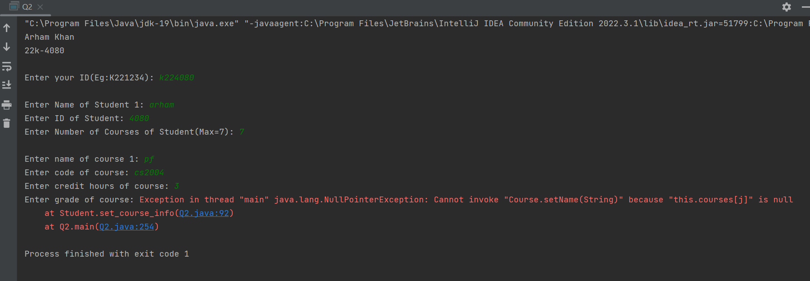

Q3:
class Product {
protected String name;
protected int price;
public Product(String name, int price) {
this.name = name;
this.price = price;
}
public Product() {}
public int get_discounted_price() {
return price;
}
public void print_details() {
System.out.println("product name: " + name + " price: " + price);
}
public Product operatorAnd(Product prod1) {
Product prod2 = new Product();
prod2.name = prod1.name + " & " + this.name;
prod2.price = (prod1.price + this.price) / 2;
return prod2;
}
}
class Book extends Product {
private String author;
public Book(String name, String author) {
super(name, 500);
this.author = author;
}
public void print_details() {
System.out.println("product name: " + name + " price: " + price + " author: " + author);
}
}
class Electronics extends Product {
private String brand;
public Electronics(String name, String brand) {
super(name, 15500);
this.brand = brand;
}
}
class Clothing extends Product {
private String size;
public Clothing(String name, String size) {
super(name, 3500);
this.size = size;
}
public int get_discounted_price() {
return (int) (price * 0.9); // 10% discount
}
}
abstract class Customer {
protected String name;
protected int balance;
public Customer(String name, int balance) {
this.name = name;
this.balance = balance;
}
public abstract void buy_product(Book book);
public abstract void buy_product(Electronics electronics);
public abstract void buy_product(Clothing clothing);
}
class RegularCustomer extends Customer {
public RegularCustomer(String name, int balance) {
super(name, balance);
}
public void buy_product(Book book) {
if (book.get_discounted_price() < balance) {
System.out.println("book bought");
balance -= book.get_discounted_price();
} else {
System.out.println("book cannot be bought");
}
}
public void buy_product(Electronics electronics) {
if (electronics.get_discounted_price() < balance) {
System.out.println("electronics bought");
balance -= electronics.get_discounted_price();
} else {
System.out.println("electronics cannot be bought");
}
}
public void buy_product(Clothing clothing) {
if (clothing.get_discounted_price() < balance) {
System.out.println("clothing bought");
balance -= clothing.get_discounted_price();
} else {
System.out.println("clothing cannot be bought");
}
}
}
class VipCustomer extends Customer {
public VipCustomer(String n, int b) {
super(n, b);
}
@Override
public void buy_product(Book book) {
if ((book.get_discounted_price() * 0.8) < balance) {
System.out.println("book bought");
balance -= book.get_discounted_price();
} else {
System.out.println("book cannot be bought");
}
}
@Override
public void buy_product(Electronics electronics) {
if ((electronics.get_discounted_price() * 0.8) < balance) {
System.out.println("electronics bought");
balance -= electronics.get_discounted_price();
} else {
System.out.println("electronics cannot be bought");
}
}
@Override
public void buy_product(Clothing cloths) {
if ((cloths.get_discounted_price() * 0.8) < balance) {
System.out.println("cloths bought");
balance -= cloths.get_discounted_price();
} else {
System.out.println("cloths cannot be bought");
}
}
}
public class Q3 {
public static void main(String[] args) {
Book book = new Book("the subtle art of giving", "charles dicken");
Electronics smartphone = new Electronics("Smartphone", "Samsung");
Clothing clothing = new Clothing("pants", "small");
RegularCustomer customer1 = new RegularCustomer("abc", 1000);
customer1.buy_product(book);
customer1.buy_product(smartphone);
VipCustomer customer2 = new VipCustomer("Richie Rich", 20000);
customer2.buy_product(smartphone);
customer2.buy_product(smartphone);
// ___________________________________________________________________
Product p1 = new Product("headphones", 60);
Product p2 = new Product("mouse", 20);
Product p3 = p1.operatorAnd(p2);
p3.print_details();
}
}
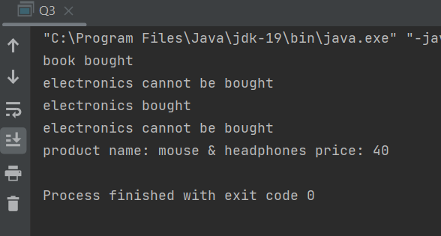

Q4:
import java.util.ArrayList;
class Game {
private ArrayList<GameObject> gameObjectList;
public Game(int n) {
gameObjectList = new ArrayList<>(n);
}
public void addGameObject(GameObject obj) {
gameObjectList.add(obj);
}
public void drawAll() {
for (GameObject obj : gameObjectList) {
obj.draw();
}
}
}
abstract class GameObject{
protected final String name;
protected int x;
protected int y;
public GameObject(int x, int y, String n) {
this.name = n;
this.x = x;
this.y = y;
}
public GameObject() {
this.name = "";
this.x = 0;
this.y = 0;
}
public abstract void draw();
}
class Player extends GameObject {
private int health;
public Player(int x, int y, String n) {
super(x, y, n);
this.health = 10;
}
public Player(int x, int y) {
this(x, y, "22K-4080");
}
@Override
public void draw() {
System.out.println("draw of Player class");
}
public boolean equals(Player obj) {
return this.health == obj.health;
}
}
class Enemy extends GameObject {
private int damage;
public Enemy(int x, int y, String n) {
super(x, y, n);
this.damage = 0;
}
public Enemy(int x, int y) {
this(x, y, "22K-4080");
}
@Override
public void draw() {
System.out.println("draw of Enemy class");
}
}
class PowerUp extends GameObject {
private int effect;
public PowerUp(int x, int y, String n) {
super(x, y, n);
this.effect = 0;
}
public PowerUp(int x, int y) {
this(x, y, "22K-4080");
}
@Override
public void draw() {
System.out.println("draw of PowerUp class");
}
}
public class Q4 {
public static void main(String[] args) {
Game game = new Game(4);
Player plyr1 = new Player(0, 0);
Enemy plyr2 = new Enemy(1, 5);
PowerUp obj = new PowerUp(2, 2);
Player plyr3 = new Player(3, 3);
game.addGameObject(plyr1);
game.addGameObject(plyr2);
game.addGameObject(obj);
game.addGameObject(plyr3);
game.drawAll();
if (plyr1.equals(plyr3)) {
System.out.println("Successfully overloaded");
}
}
}

